NAME: DISHANT ARORA
REG. NO.: 180905462
PP LAB
WEEK 4

Q1.(Sum of N factorials using N processes)
#include "mpi.h"
#include <stdio.h>
#include <string.h>

int main(int argc,char* argv[])
{
int rank, size,ierr;
int i = 0;
int res = 0,fact = 1;
MPI_Init(&argc, &argv);
MPI_Comm_rank(MPI_COMM_WORLD, &rank);
MPI_Comm_size(MPI_COMM_WORLD, &size);
MPI_Errhandler_set(MPI_COMM_WORLD,MPI_ERRORS_RETURN);

for (i = 1;i <= rank+1;i++)
{
fact = fact*i;
}
MPI_Scan(&fact,&res,1,MPI_INT,MPI_SUM,MPI_COMM_WORLD);
if (rank == size-1)
{
printf("%d\n",res);
}
MPI_Finalize();
return 0;
}

OUTPUT:
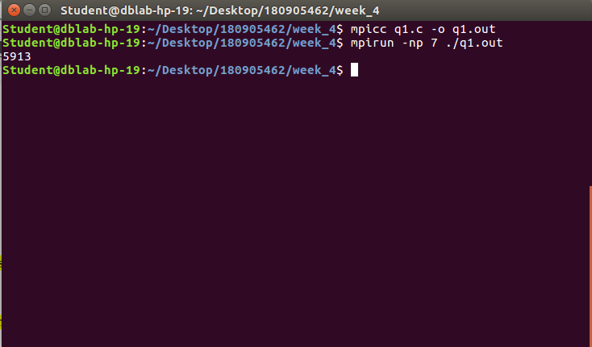

Q2.(Calculating the value of pi)
#include <stdio.h>
#include "mpi.h"

int main(int argc, char *argv[])
{
int rank,size,i;
float rect,pi;
MPI_Init(&argc,&argv);
MPI_Comm_rank(MPI_COMM_WORLD,&rank);
MPI_Comm_size(MPI_COMM_WORLD,&size);

float x=(rank+0.5)/size;
float x2=x*x;
rect=(4/(1+x2))*(1/(float)size);

MPI_Reduce(&rect,&pi,1,MPI_FLOAT,MPI_SUM,0,MPI_COMM_WORLD);
if(rank==0)
printf("Value of pi=%f\n",pi);

MPI_Finalize();
return 0;
}

OUTPUT:
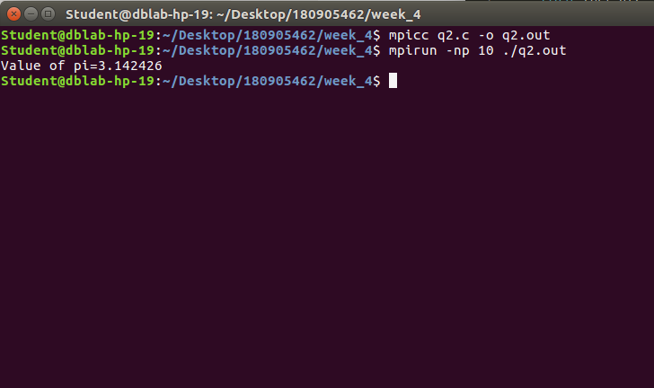

Q3.(Calculating the number of occurances of a number in a 3x3 matrix)
#include "mpi.h"
#include <math.h>
#include <stdio.h>
#include <string.h>
#include <stdlib.h>
int main(int argc, char *argv[])
{
int rank, size, a[3][3], i,j, b[3], n, x,c =0,s=0;
MPI_Status status;
MPI_Init(&argc,&argv);
MPI_Comm_rank(MPI_COMM_WORLD, &rank);
MPI_Comm_size(MPI_COMM_WORLD, &size);
if(rank==0)
{
printf("Root Process: Enter 3x3 Matrix:\n");
for(i=0;i<3;i++)
{
for(j=0;j<3;j++)
{
scanf("%d",&a[i][j]);
}
}
printf("Enter Number to be searched:");
scanf("%d",&n);

for(i=1;i<4;i++)
{
MPI_Send(a[i-1], 3, MPI_INT, i, 1, MPI_COMM_WORLD);
}

}
MPI_Bcast(&n, 1, MPI_INT,0,MPI_COMM_WORLD);
if(rank!=0)
MPI_Recv(b, 3, MPI_INT, 0,1, MPI_COMM_WORLD, &status);

if(rank!=0)
for(i=0;i<3;i++)
{
if(b[i]==n)
c++;
}
MPI_Reduce(&c, &s,1,MPI_INT, MPI_SUM,0, MPI_COMM_WORLD);
if(rank==0)
{
printf("Rank = %d Number of Occurences = %d\n", rank, s);
}
MPI_Finalize();
}
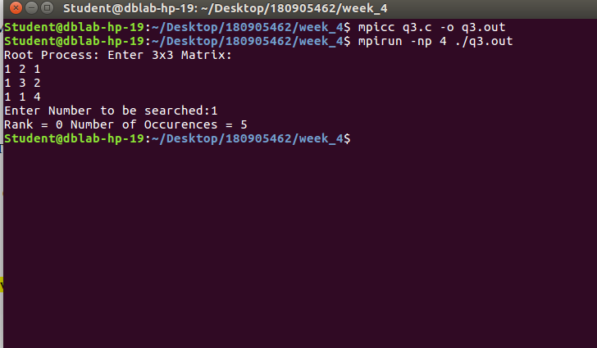
OUTPUT:

Q4.(Calculating row-wise cumulative sum of a 4x4 matrix using 4 processes)

OUTPUT:

